I
n this session we will look at what is cancel event and how it functions ?.

Cancel event is used to cancel the transaction and to trigger compensation.

Types of compensation events
- End cancel event
- Intermediate boundary cancel event

Camunda Cancel Event


Cancel end event

The cancel end event can only be used in combination with a transaction subprocess. When the cancel end event is reached, a cancel event is thrown which must be caught by a cancel boundary event. The cancel boundary event then cancels the transaction and triggers compensation.


Cancel boundary event

An attached intermediate catching cancel event on the boundary of a transaction subprocess is triggered when a transaction is canceled. When the cancel boundary event is triggered, it first interrupts all executions active in the current scope. Next, it starts compensation of all active compensation boundary events in the scope of the transaction.
Compensation is performed synchronously, i.e. the boundary event waits before compensation is completed before leaving the transaction. When compensation is completed, the transaction subprocess is left using the sequence flow(s) running out of the cancel boundary event.

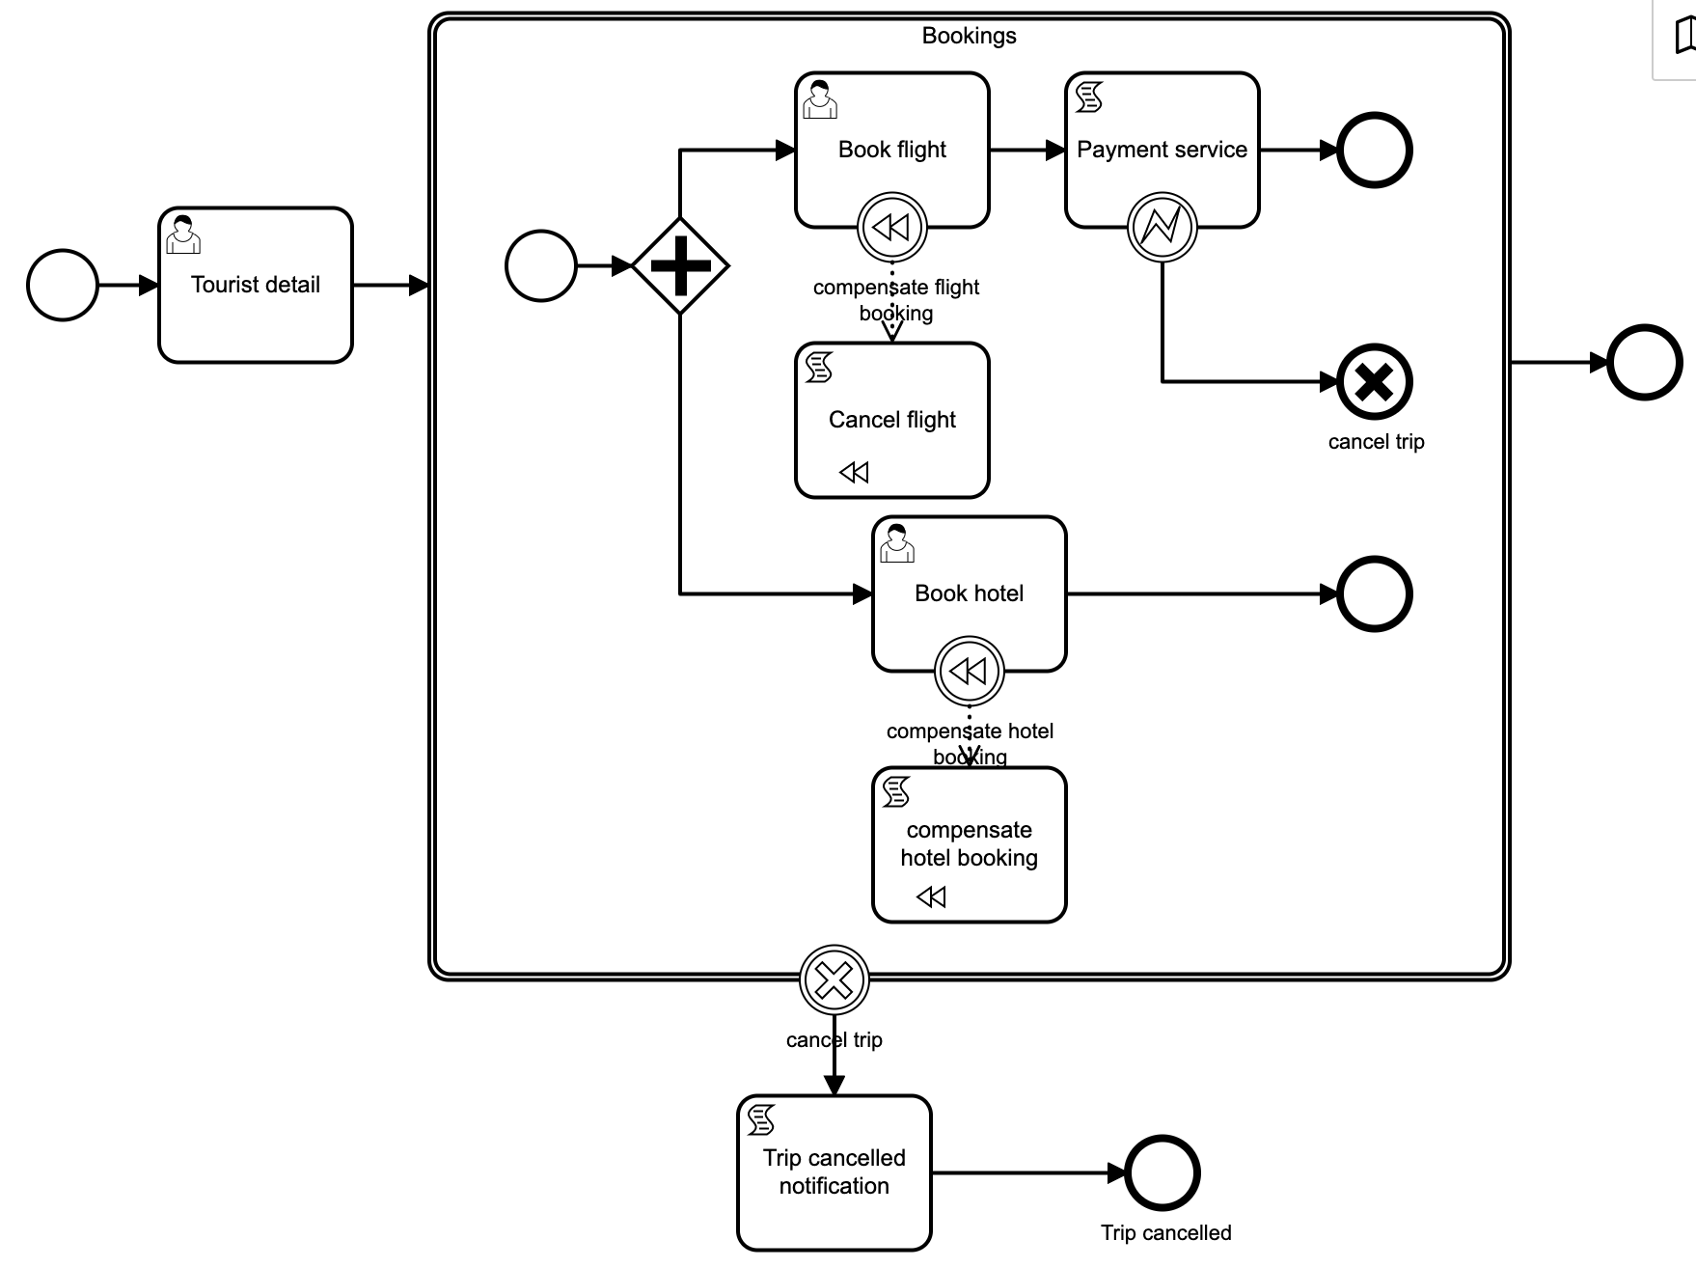
1. To demonstrate the use of cancel event we will use following process diagram.

Properties:
Id: Process_Cancel_Event
Name: Process cancel event

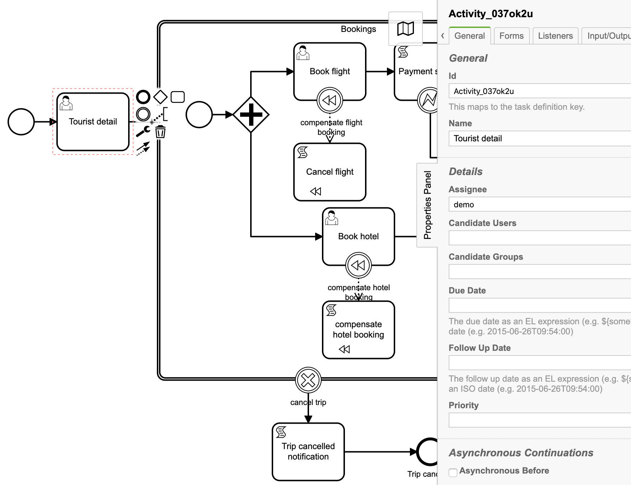
2. User task: Tourist detail
Id: Activity_037ok2u
Name: Tourist detail
Assignee: demo

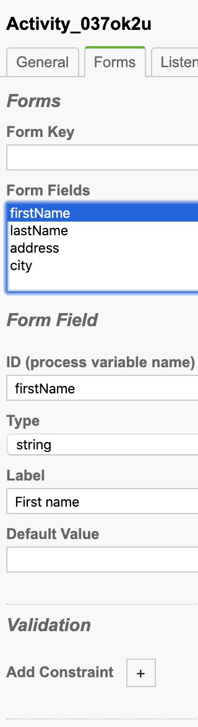
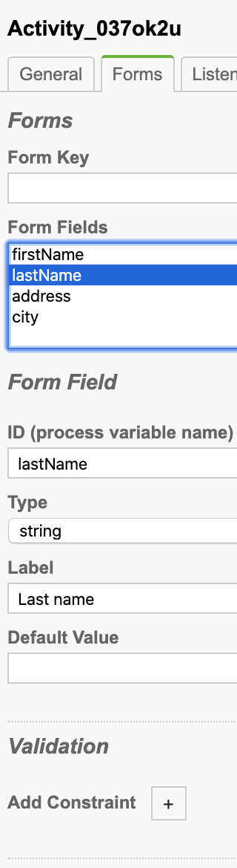
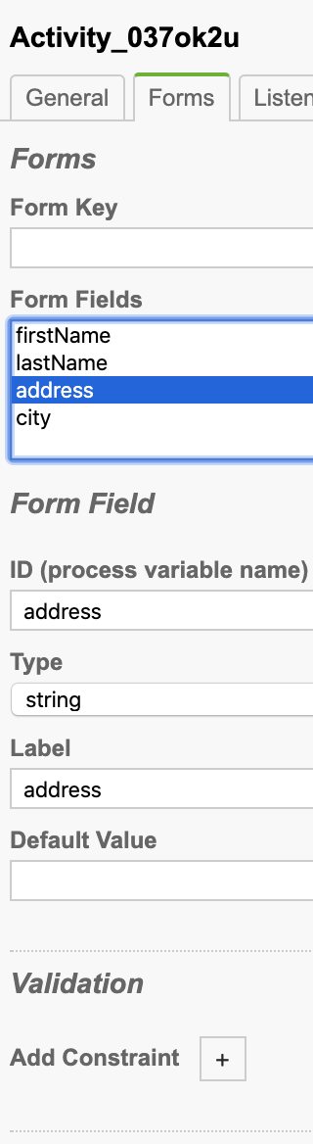
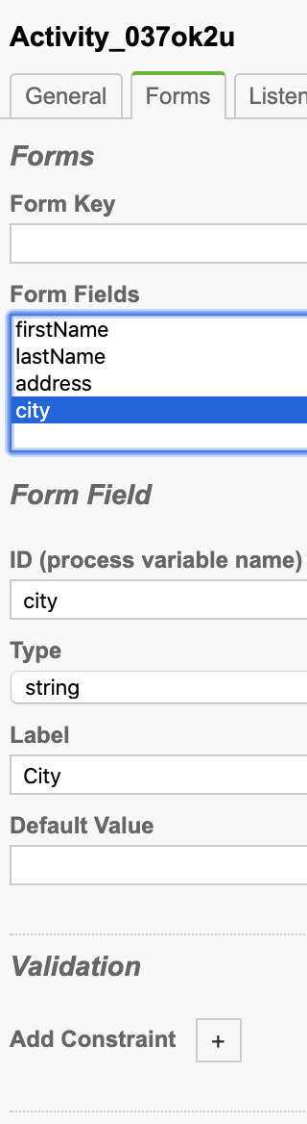
Task form:

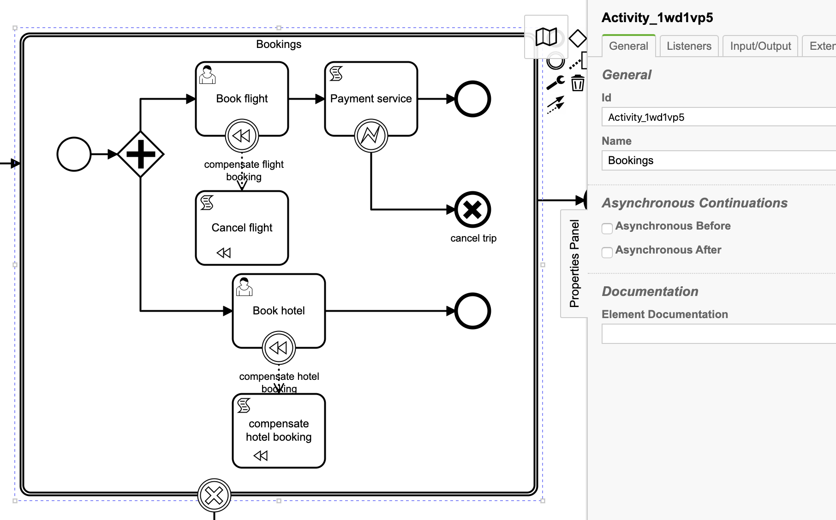
3. Transactional sub process: Bookings
Id: Activity_1wd1vp5
Name: Bookings

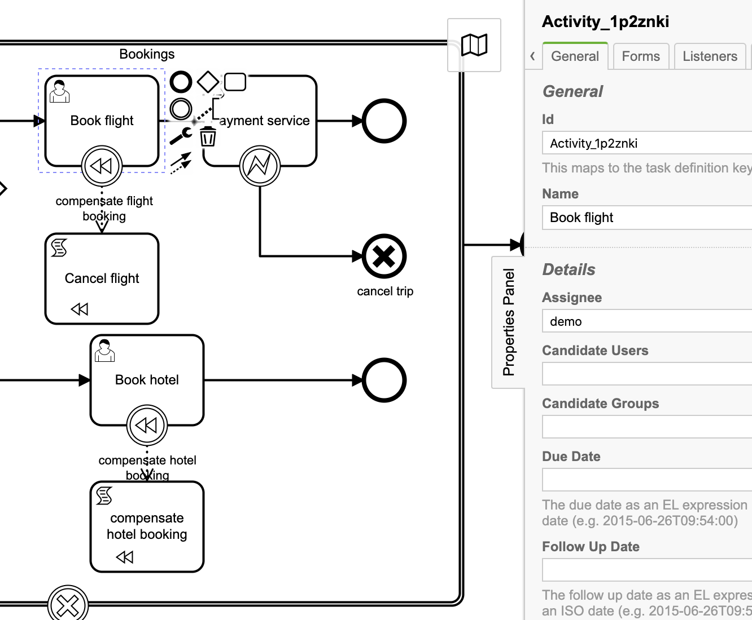
4. User task: Book flight
Id: Activity_1p2znki
Name: Book flight
Assignee: demo

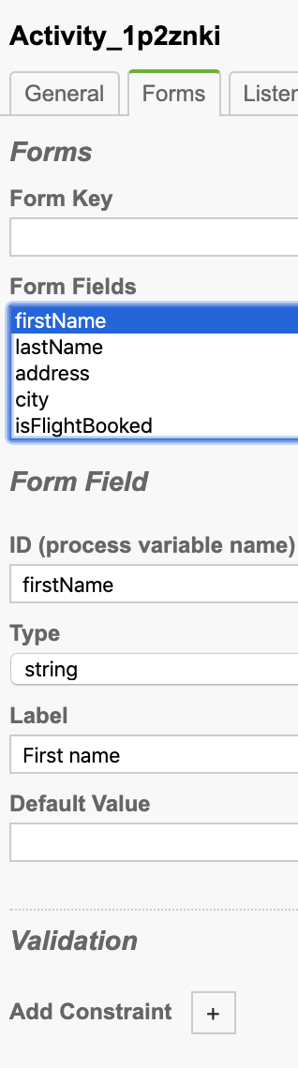
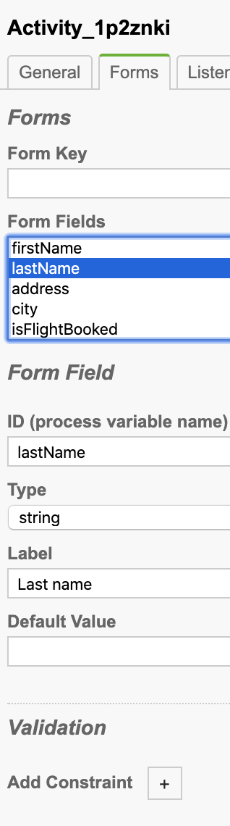
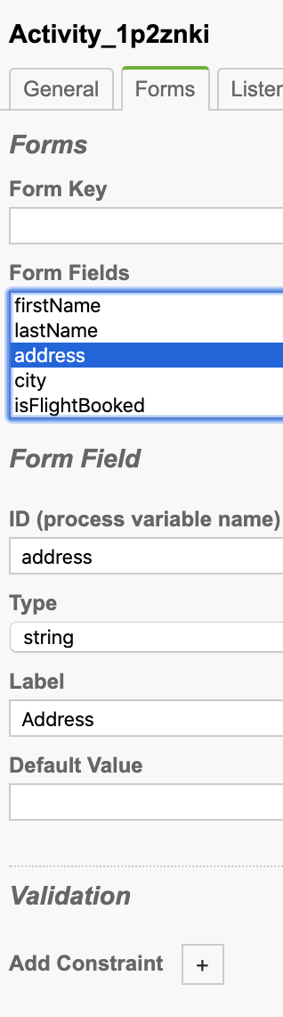
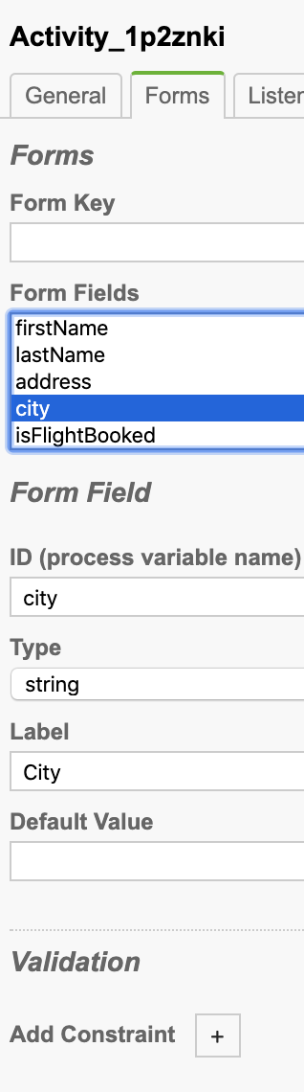
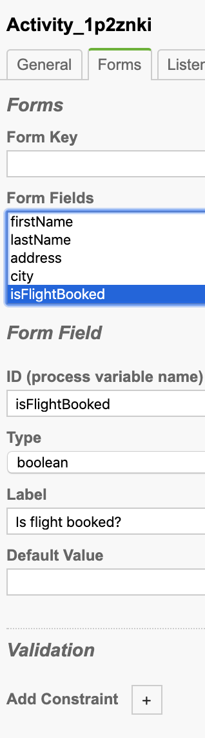
Task form:

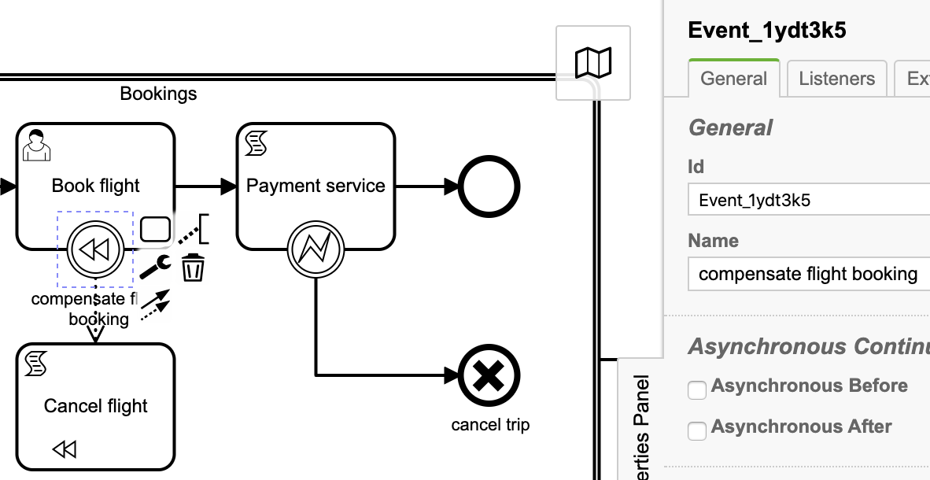
5. Boundary compensate event
Id: Event_1ydt3k5
Name: compensate flight booking

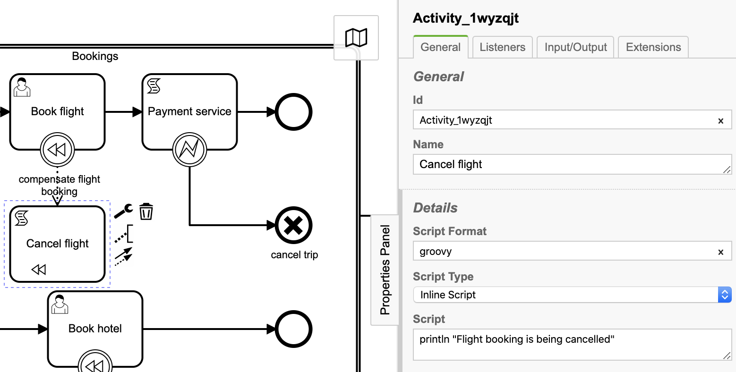
6. Script task: Cancel flight
Id: Activity_1wyzqjt
Name: Cancel flight
Script Format: groovy
Script Type: Inline Script
Script:
println "Flight booking is being cancelled"

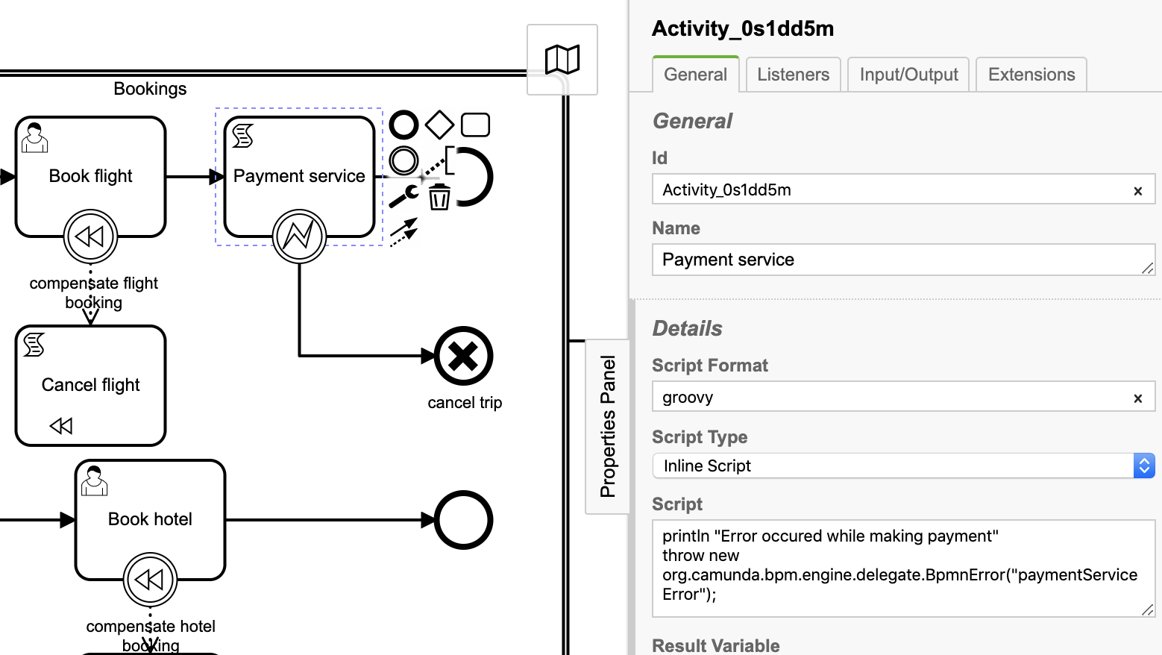
7. Script task: Payment service
Id: Activity_0s1dd5m
Name: Payment service
Script Format: groovy
Script Type: Inline Script
Script:
println "Error occured while making payment"
throw new org.camunda.bpm.engine.delegate.BpmnError("paymentServiceError");

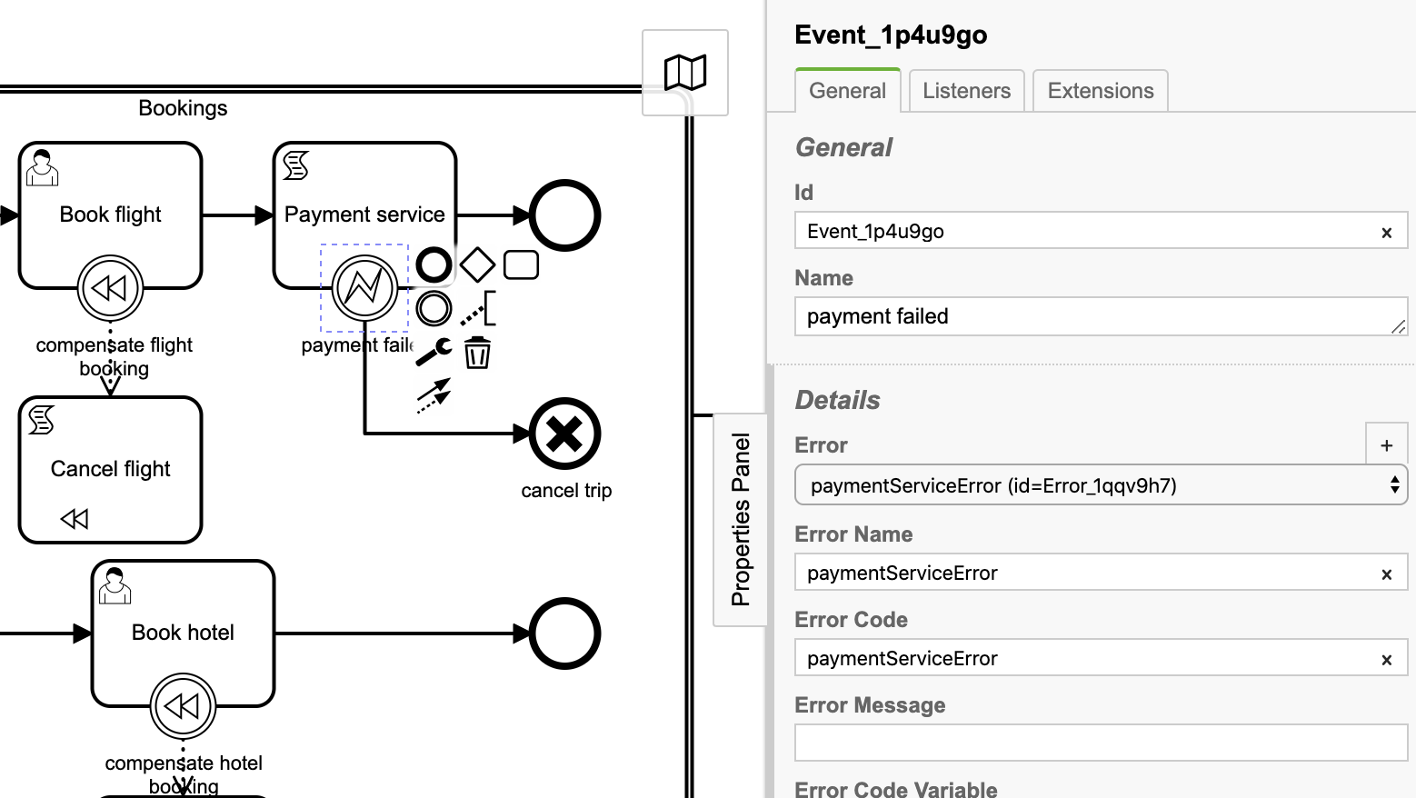
8. Boundary error event: Payment failed

Id: Event_1p4u9go
Name: payment failed
Error: paymentServiceError (id=Error_1qqv9h7)
Error Name: paymentServiceError
Error Code: paymentServiceError

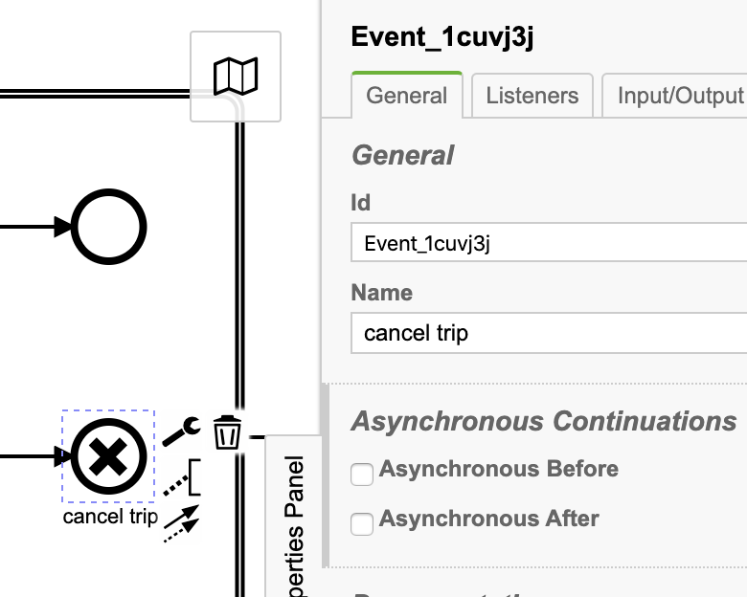
9. Cancel end event: cancel trip

Id: Event_1cuvj3j
Name: cancel trip

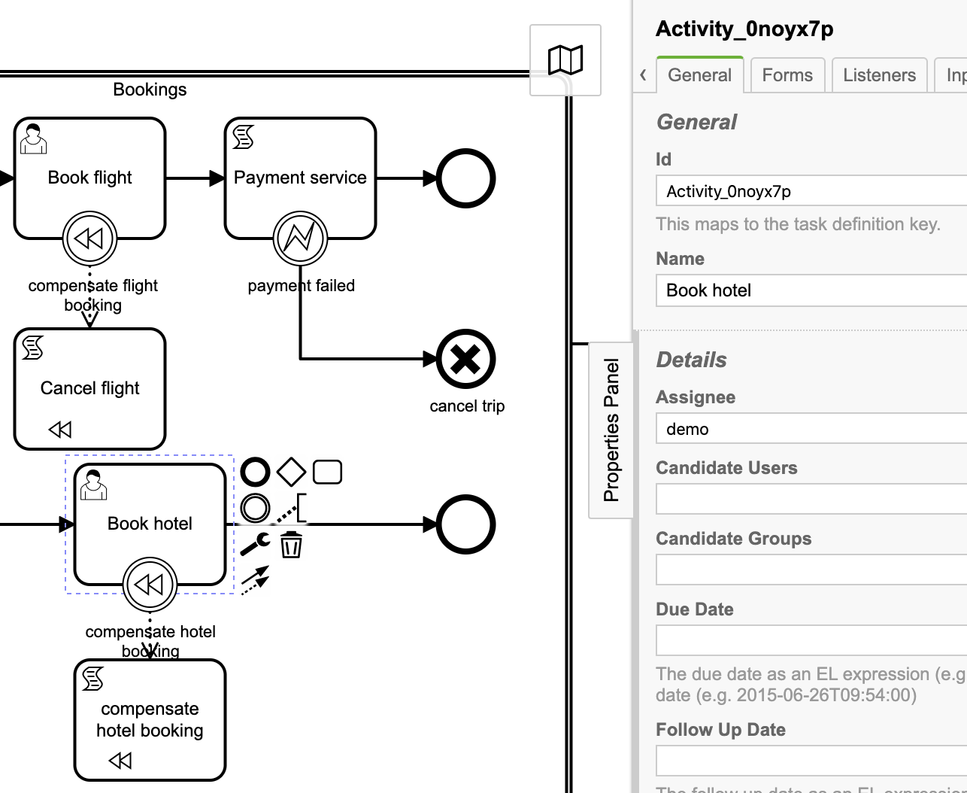
10. User task: Book hotel

Id: Activity_0noyx7p
Name: Book hotel
Assignee: demo

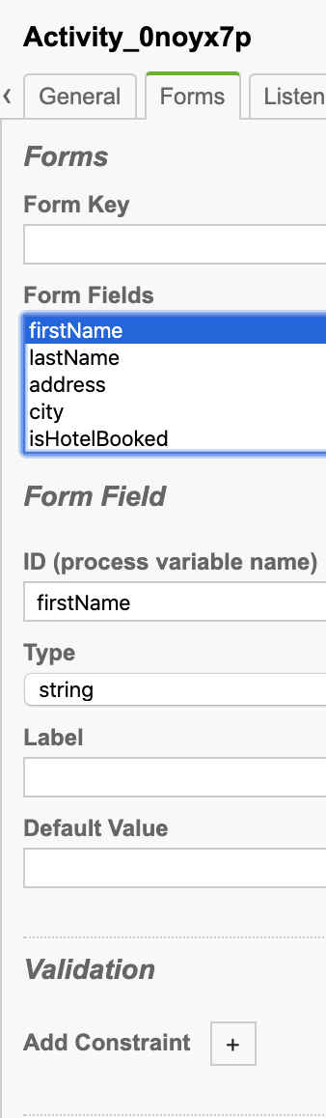
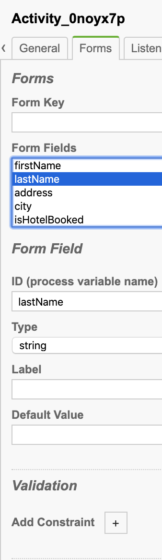
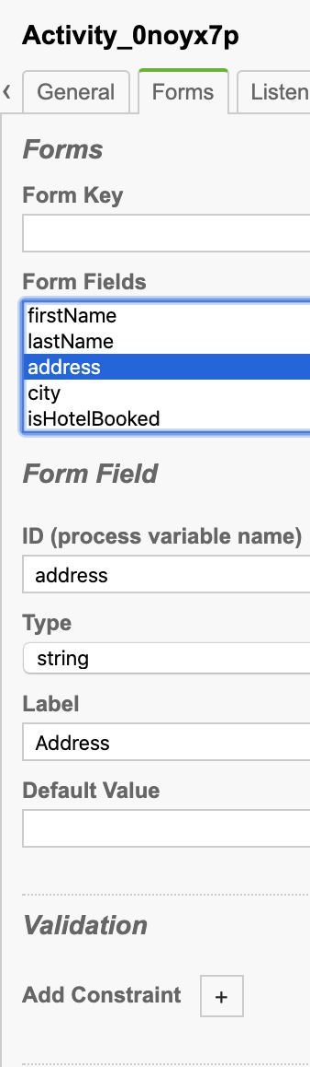
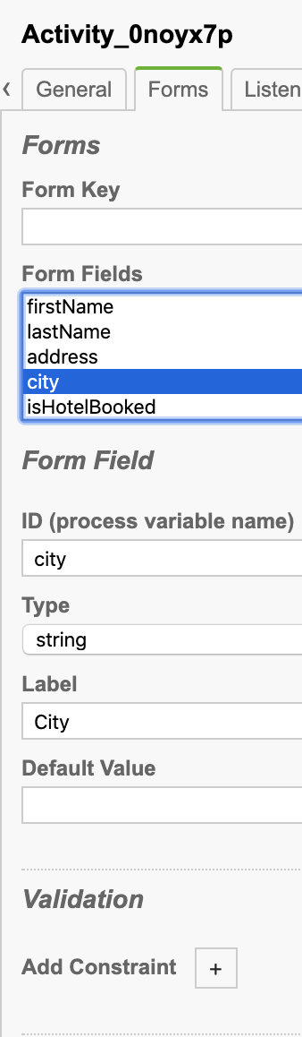
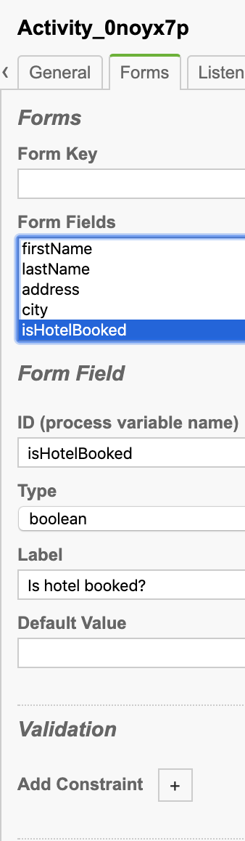
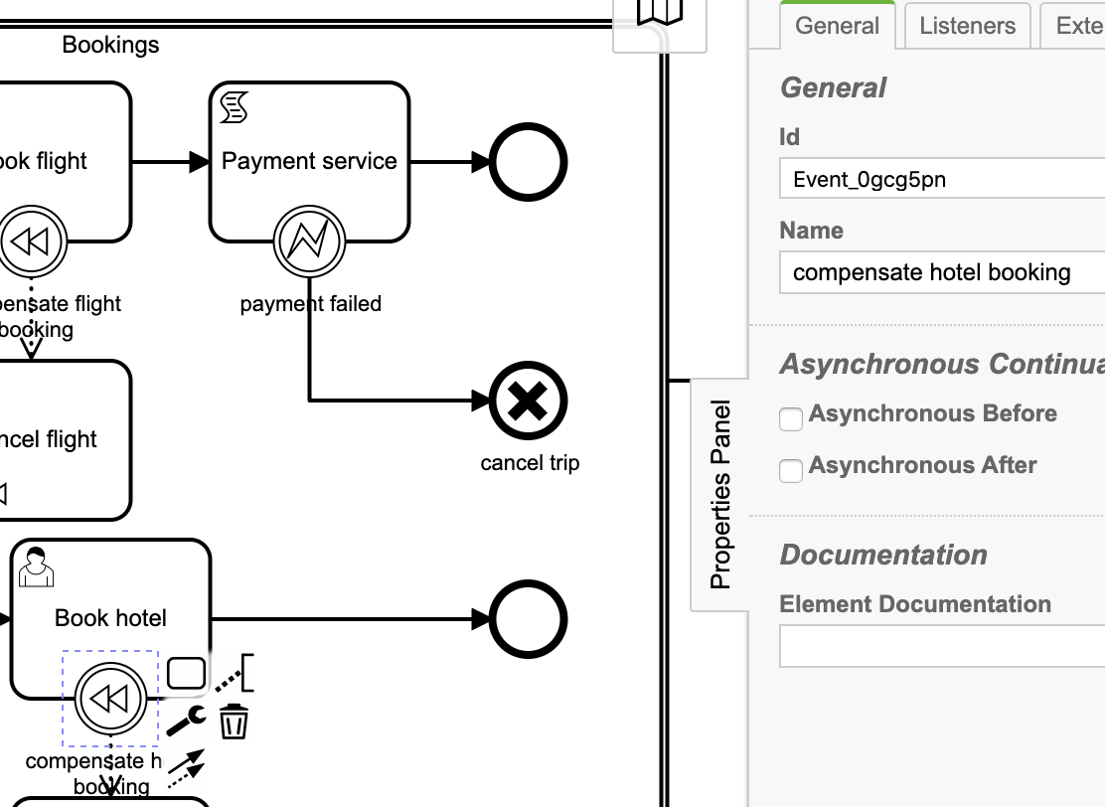
Task form:

11. Boundary compensate event: compensate hotel booking

Id: Event_0gcg5pn
Name: compensate hotel booking

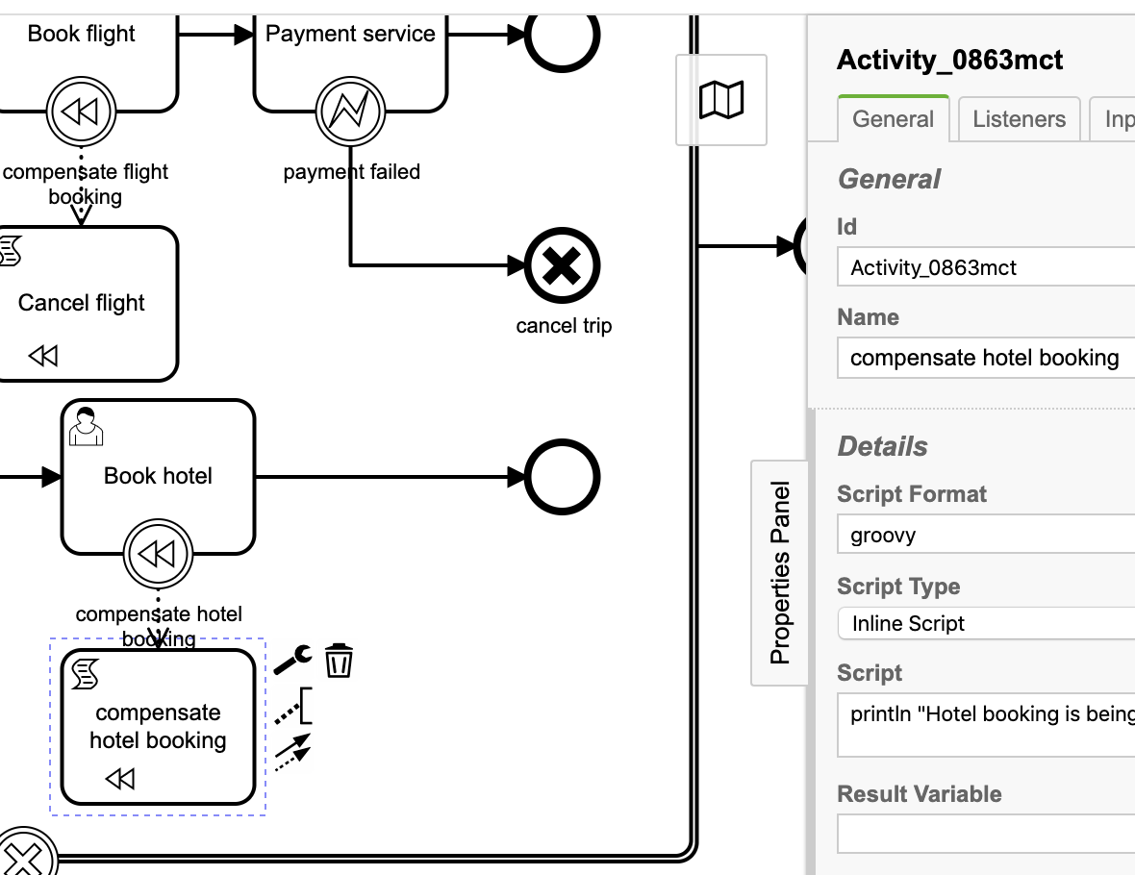
11. Script task: compensate hotel booking
Id: Activity_0863mct
Name: compensate hotel booking
Script Format: groovy
Script Type: Inline Script
Script:
println "Hotel booking is being cancelled"

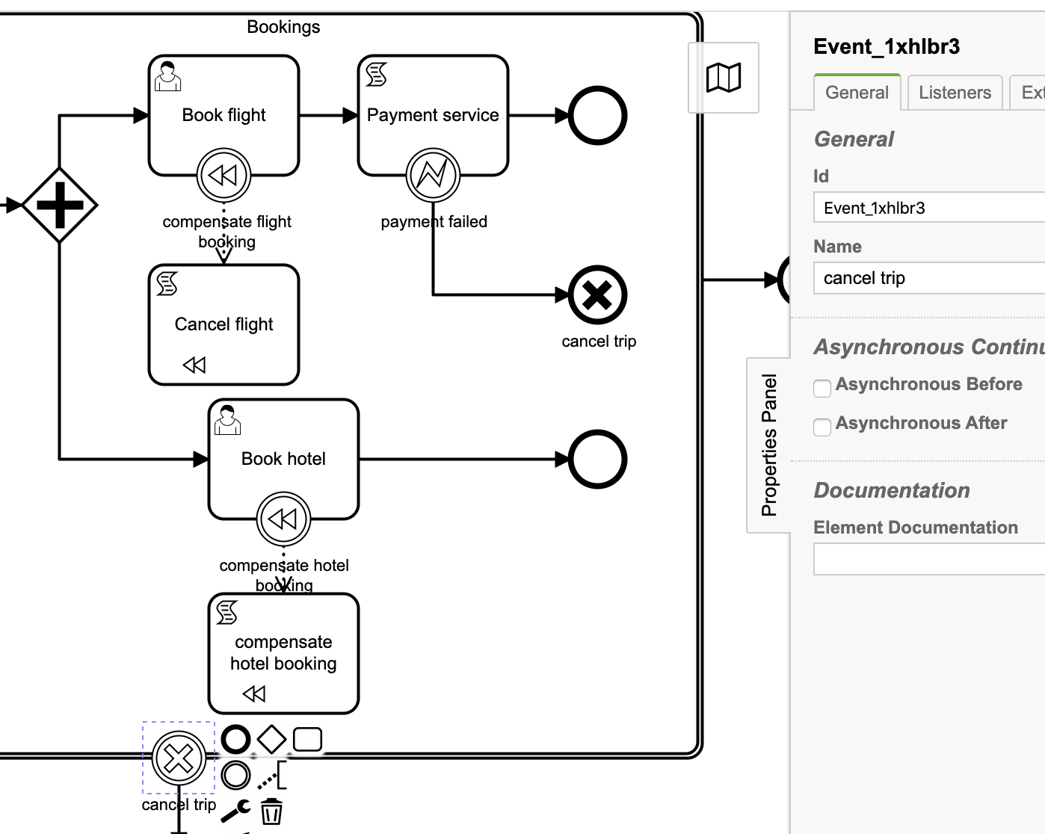
12. Boundary cancel event: cancel trip
Id: Event_1xhlbr3
Name: cancel trip

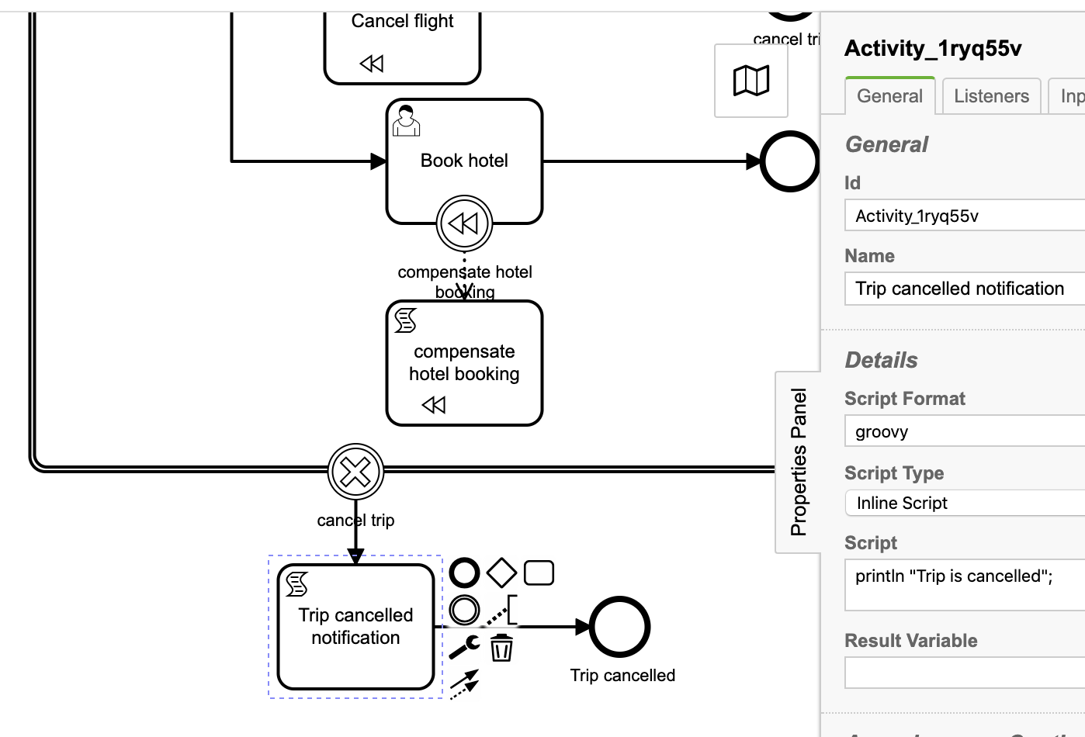
13. Trip cancelled notification

Id: Activity_1ryq55v
Name: Trip cancelled notificationScript Format: groovy
Script Type: Inline Script
Script:
println "Trip is cancelled”;

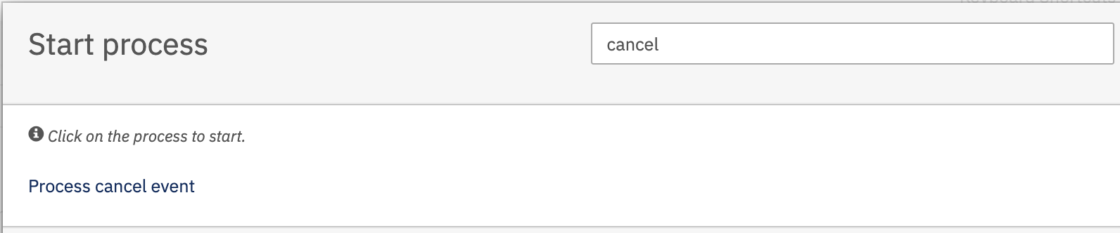
14. Deploy and start the process
Hit the process cancel event and hit the Start button to start the process.

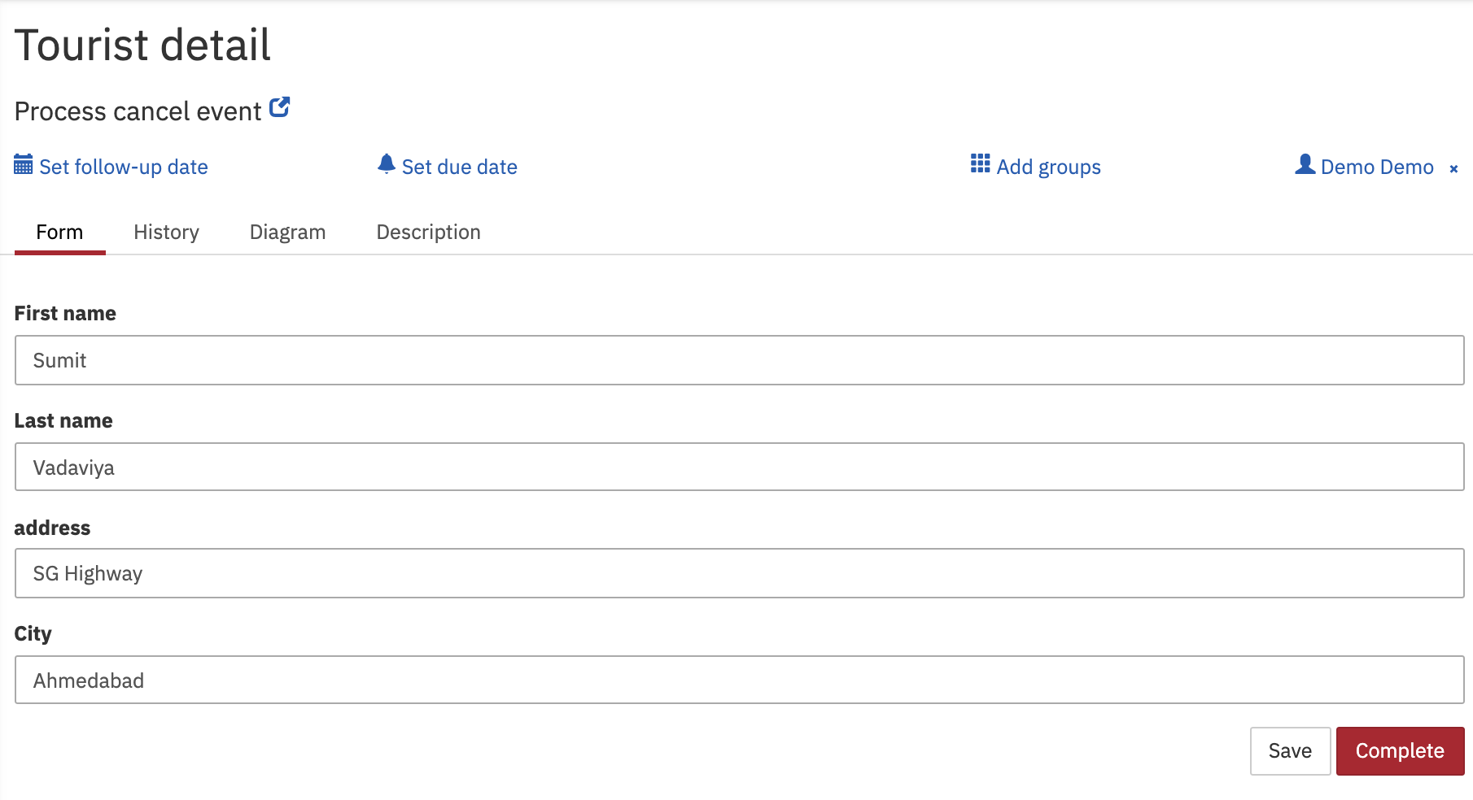
User task Tourist detail will get created as per process definition.
Fill-up the user task form and hit the Complete button.
As per process definition, two user tasks Book hotel and Book flight user task will get created simultaneously.

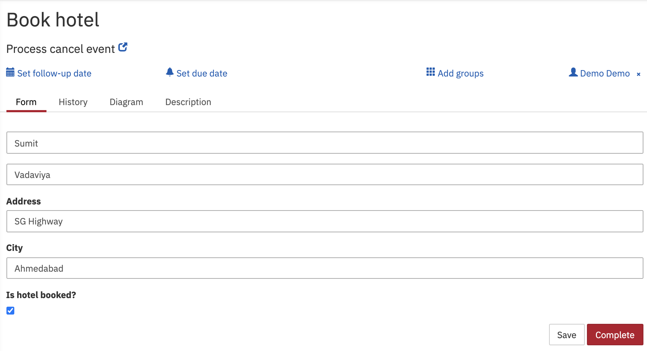
Lets first complete the user task Book hotel
Fill-up the user task form and hit the Complete button.

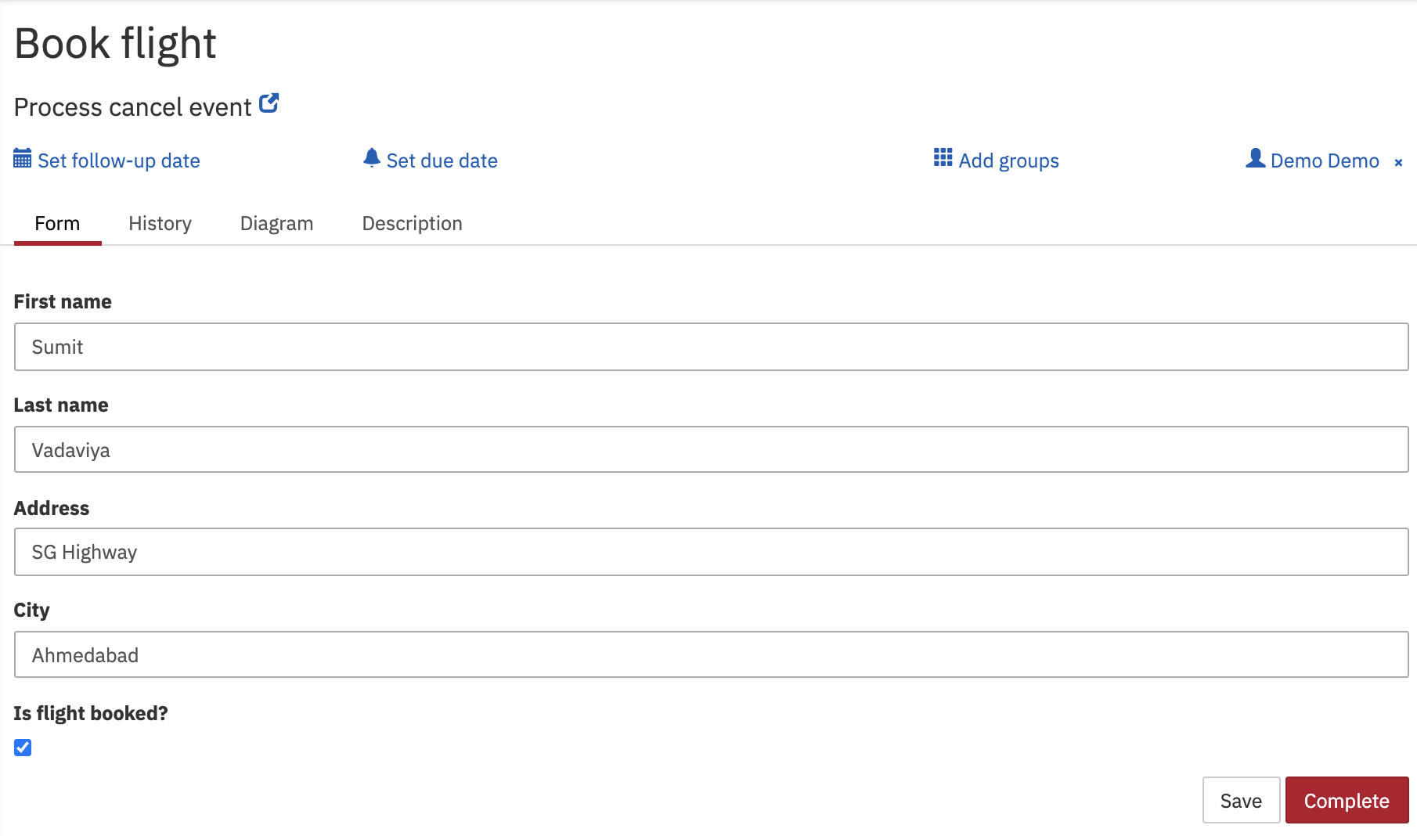
Similarly, complete the user task Book flight
Fill-up the user task form and hit the Complete button.

As per process definition, after completion of user task Book flight, script task payment service will execute and it will throw error which will be caught by boundary error event payment failed then end cancel event will get triggered which will be caught by boundary cancel event cancel trip and on execution of boundary cancel event it will execute all the compensate event inside the sub process to compensate the user tasks.

Observe the tomcat console logs
Error occured while making payment
Flight booking is being cancelled
Hotel booking is being cancelled
Trip is cancelled

